**Case Study on Foodie-Fi**

1. How many customers has Foodie-Fi ever had?

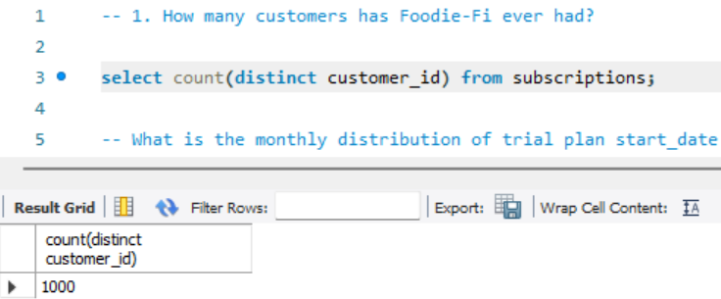

2. What is the monthly distribution of trial plan start_date values for our dataset - use the start of the month as the group by value.

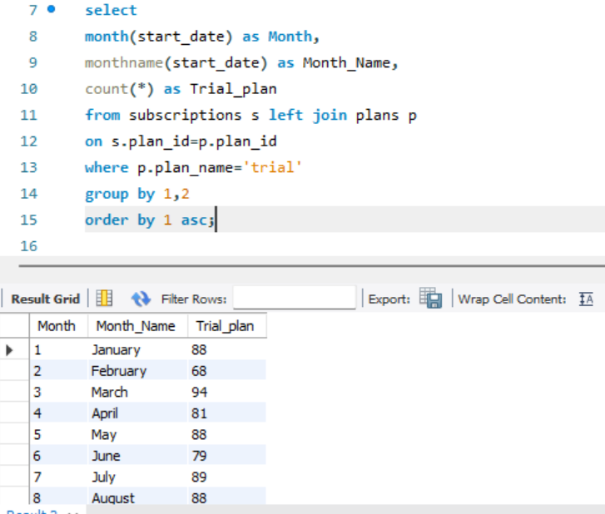

3. What plan start_date values occur after the year 2020 for our dataset? Show the breakdown by count of events for each plan_name.

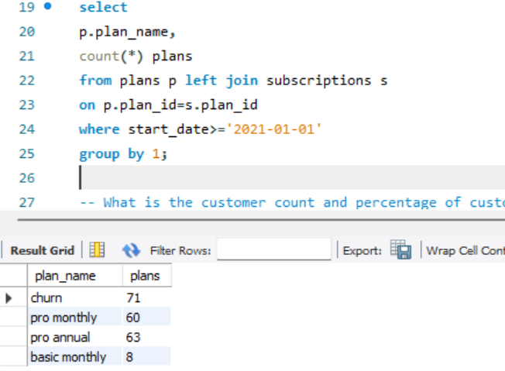

4. What is the customer count and percentage of customers who have churned rounded to 1 decimal place?

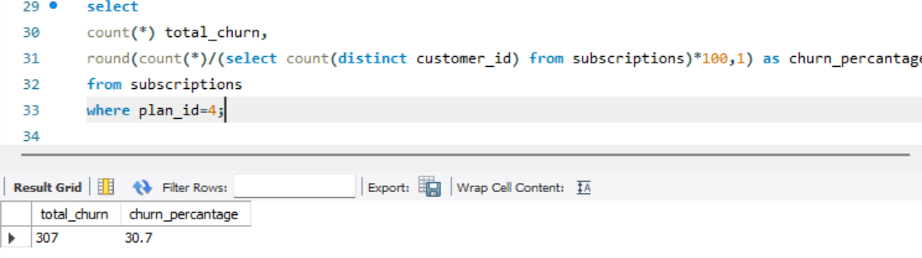

5. How many customers have churned straight after their initial free trial - what percentage is this rounded to 1 decimal place?

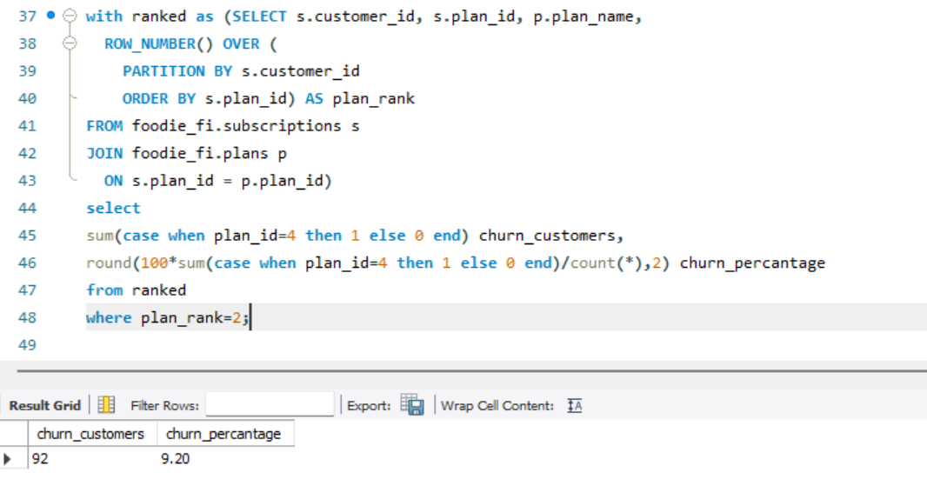

6. What is the number and percentage of customer plans after their initial free trial?

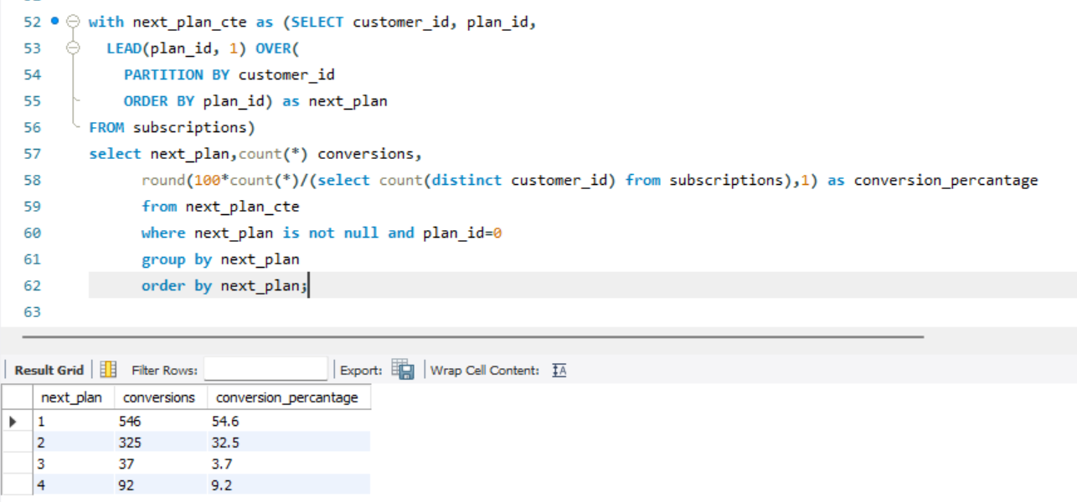

7. What is the customer count and percentage breakdown of all 5 plan_name values at 2020-12-31?

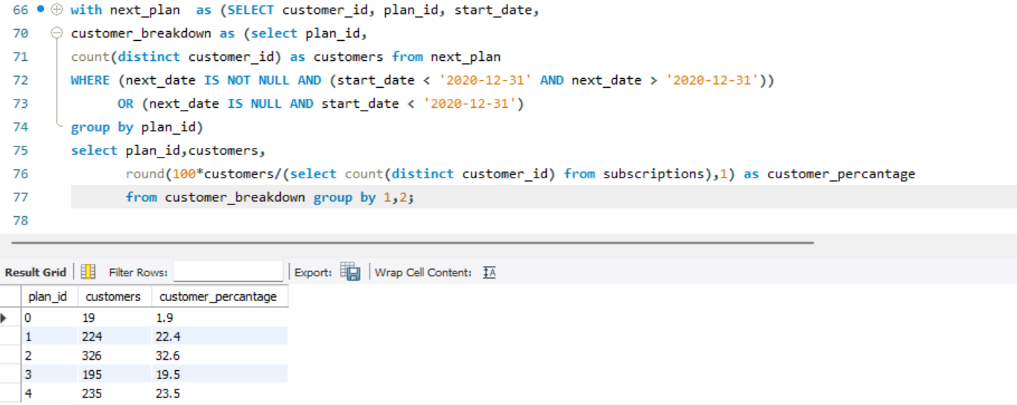

8.How many customers have upgraded to an annual plan in 2020?

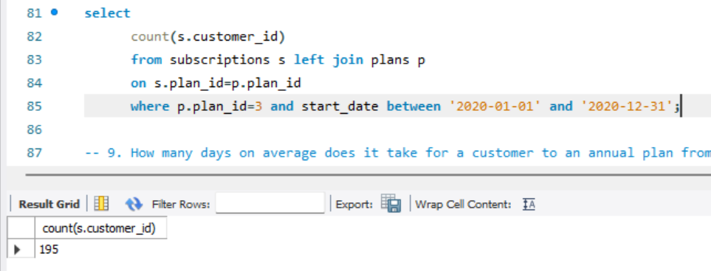

9. How many days on average does it take for a customer to an annual plan from the day they join Foodie-Fi?

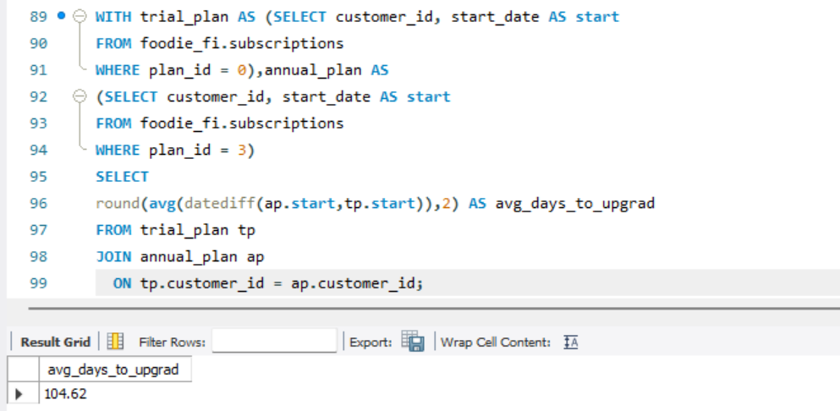

10. Can you further breakdown this average value into 30-day periods (i.e. 0–30 days, 31–60 days, etc).

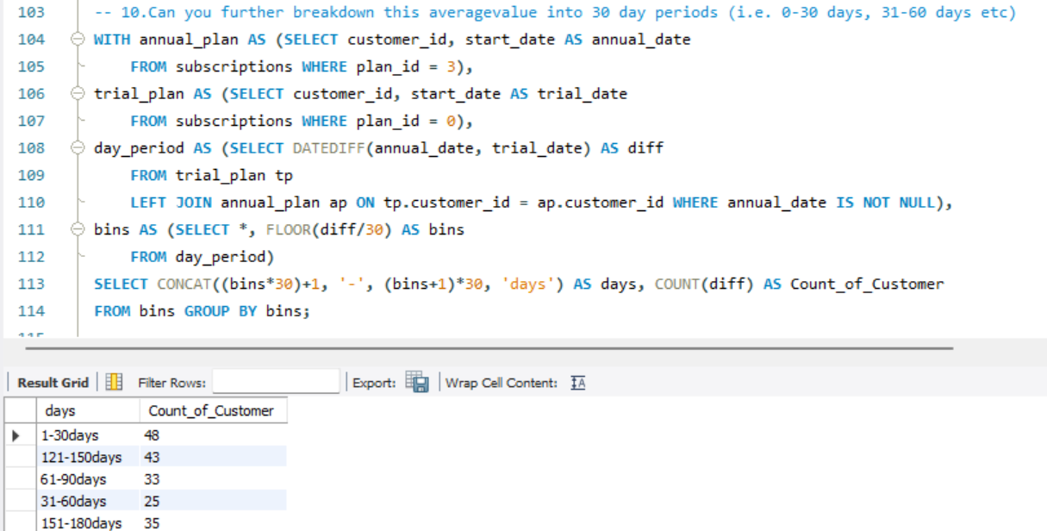

11. How many customers were downgraded from a pro monthly to a basic monthly plan in 2020?

